31 Ağu 2021

MATPLOTLIB

# **Intermediate(Legend guide)**

1. Legend Yeri Belirleme

* [plt.legend](https://matplotlib.org/stable/api/_as_gen/matplotlib.pyplot.legend.html#matplotlib.pyplot.legend)(bbox_to_anchor=(1, 1),

bbox_transform=plt.gcf().transFigure) # (1,1) değerini vererek Legend’in üst sağ köşede olmasını sağlarız.

* [plt.legend](https://matplotlib.org/stable/api/_as_gen/matplotlib.pyplot.legend.html#matplotlib.pyplot.legend)(bbox_to_anchor=(0., 1.02, 1., .102), loc='lower left',

ncol=2, mode="expand", borderaxespad=0.) # Mode parametresini expand seçerek Legend’in grafik boyu olmasını sağlarız.

1. Çoklu Legendler ekleme

* [first_legend](https://matplotlib.org/stable/api/legend_api.html#matplotlib.legend.Legend) = [plt.legend](https://matplotlib.org/stable/api/_as_gen/matplotlib.pyplot.legend.html#matplotlib.pyplot.legend)(handles=[[line1](https://matplotlib.org/stable/api/_as_gen/matplotlib.lines.Line2D.html#matplotlib.lines.Line2D)], loc='upper right')

*# Legend grafiğe eklenir*

[plt.gca](https://matplotlib.org/stable/api/_as_gen/matplotlib.pyplot.gca.html#matplotlib.pyplot.gca)().add_artist([first_legend](https://matplotlib.org/stable/api/legend_api.html#matplotlib.legend.Legend))

*# Başka bir legend daha oluşturulup gösterilir.*

[plt.legend](https://matplotlib.org/stable/api/_as_gen/matplotlib.pyplot.legend.html#matplotlib.pyplot.legend)(handles=[[line2](https://matplotlib.org/stable/api/_as_gen/matplotlib.lines.Line2D.html#matplotlib.lines.Line2D)], loc='lower right')

* [red_dot](https://matplotlib.org/stable/api/_as_gen/matplotlib.lines.Line2D.html#matplotlib.lines.Line2D), = [plt.plot](https://matplotlib.org/stable/api/_as_gen/matplotlib.pyplot.plot.html#matplotlib.pyplot.plot)([z](https://docs.scipy.org/doc/numpy/reference/generated/numpy.ndarray.html#numpy.ndarray), "ro", markersize=15)

*# Kırmızı marker’ın üstüne beyaz marker yerleştirilir.*

[white_cross](https://matplotlib.org/stable/api/_as_gen/matplotlib.lines.Line2D.html#matplotlib.lines.Line2D), = [plt.plot](https://matplotlib.org/stable/api/_as_gen/matplotlib.pyplot.plot.html#matplotlib.pyplot.plot)([z](https://docs.scipy.org/doc/numpy/reference/generated/numpy.ndarray.html#numpy.ndarray)[:5], "w+", markeredgewidth=3, markersize=15)

[plt.legend](https://matplotlib.org/stable/api/_as_gen/matplotlib.pyplot.legend.html#matplotlib.pyplot.legend)([[red_dot](https://matplotlib.org/stable/api/_as_gen/matplotlib.lines.Line2D.html#matplotlib.lines.Line2D), ([red_dot](https://matplotlib.org/stable/api/_as_gen/matplotlib.lines.Line2D.html#matplotlib.lines.Line2D), [white_cross](https://matplotlib.org/stable/api/_as_gen/matplotlib.lines.Line2D.html#matplotlib.lines.Line2D))], ["Attr A", "Attr A+B"]) # Legend’leri üst üste koymanın yöntemi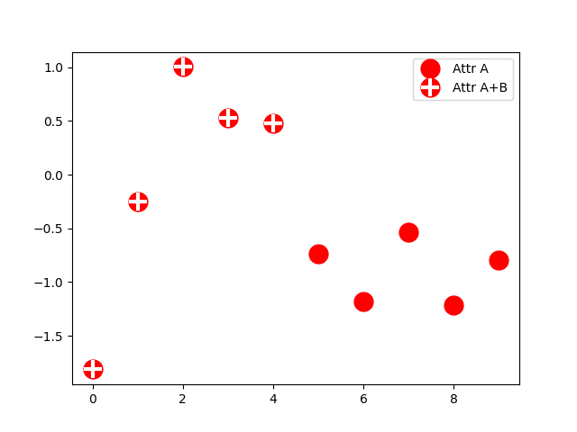

Referanslar:

https://matplotlib.org/stable/tutorials/intermediate/legend_guide.html#sphx-glr-tutorials-intermediate-legend-guide-py